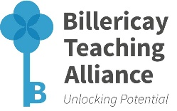
Secondary Subject Networks
MULTIPLE ATTENDEE BOOKING FORM

School Name

Network Subject | Delegate Name | Position in School | Delegate Email Address: | Exam Board for Subject of network booked | Date of Meeting

Network Attendance Fee - £50 per school per academic year. Schools can send as many teaching staff to as many of the networks as they wish for this £50 fee.

Billericay Teaching Alliance members – networks are FREE as they are included in their annual membership fee. For further information on the benefits of becoming a member, visit http://www.billericayteachingalliance.com/ta-membership/

For further information please contact: Nithya Karthikeyan (TA Administrator), Billericay Teaching Alliance c/o The Billericay School, School Road, Billericay, CM12 9LH T: 01277 314430 E: nkarthikeyan@billericayschool.com

